How to install Windows Server 2019 in a Virtual Machine

1. 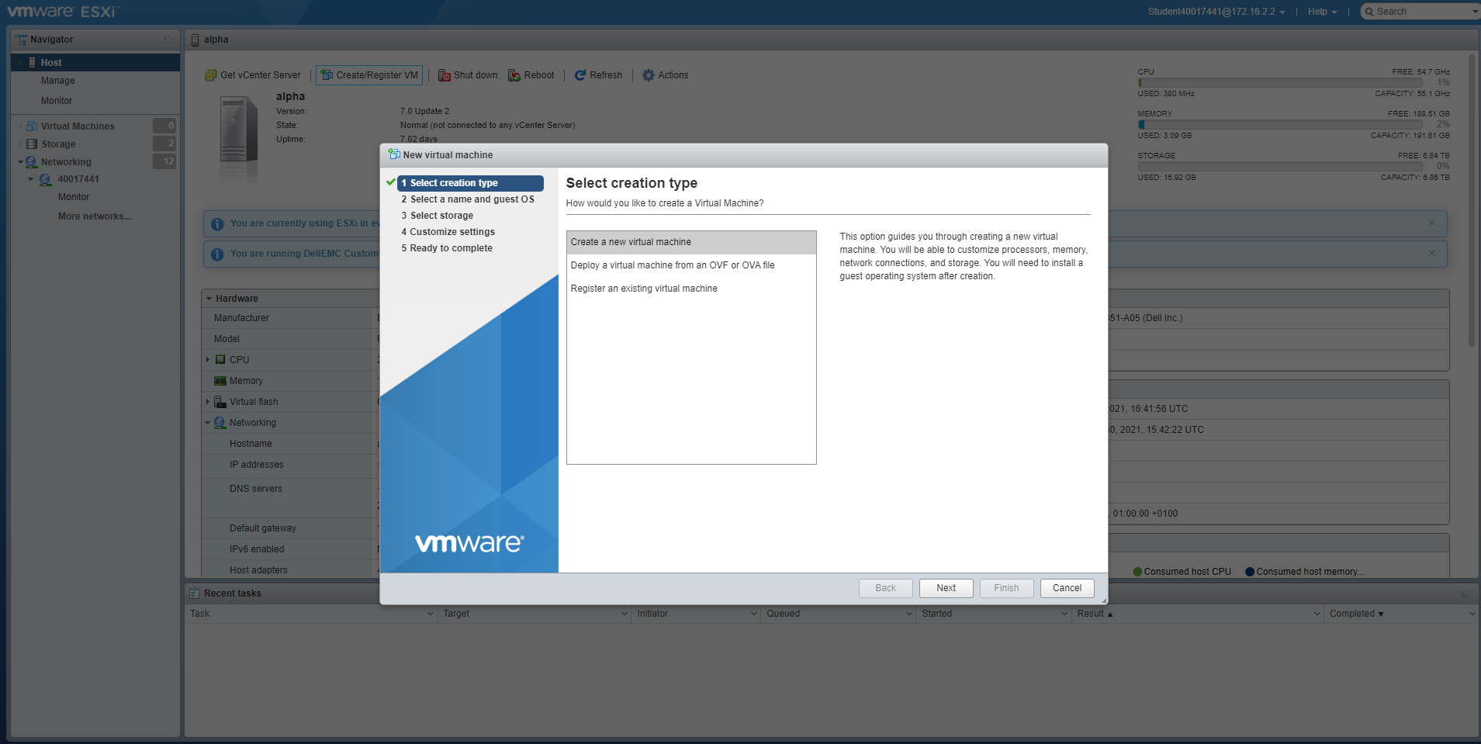Firstly, open your virtual machine – for this I’m using VMware – and select ‘Create a new virtual machine
2. 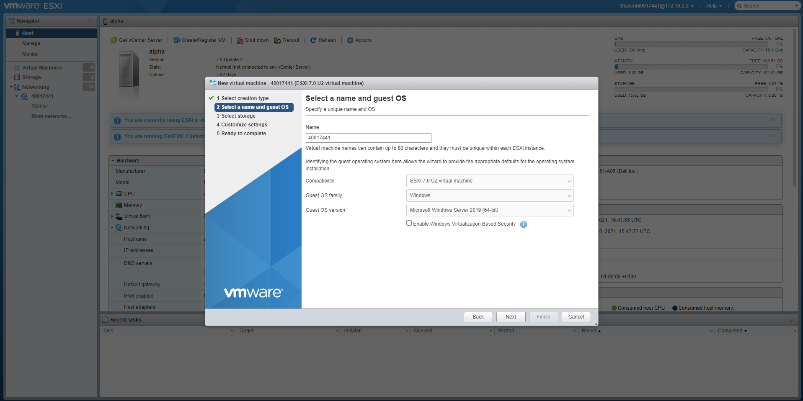Then you need to decide what to call the machine, for this I used my student number – ‘40017441’, you then need to decide what it’s compatible with and select the OS options you’re intending to install, which in this case is Windows Server 2019.
3. 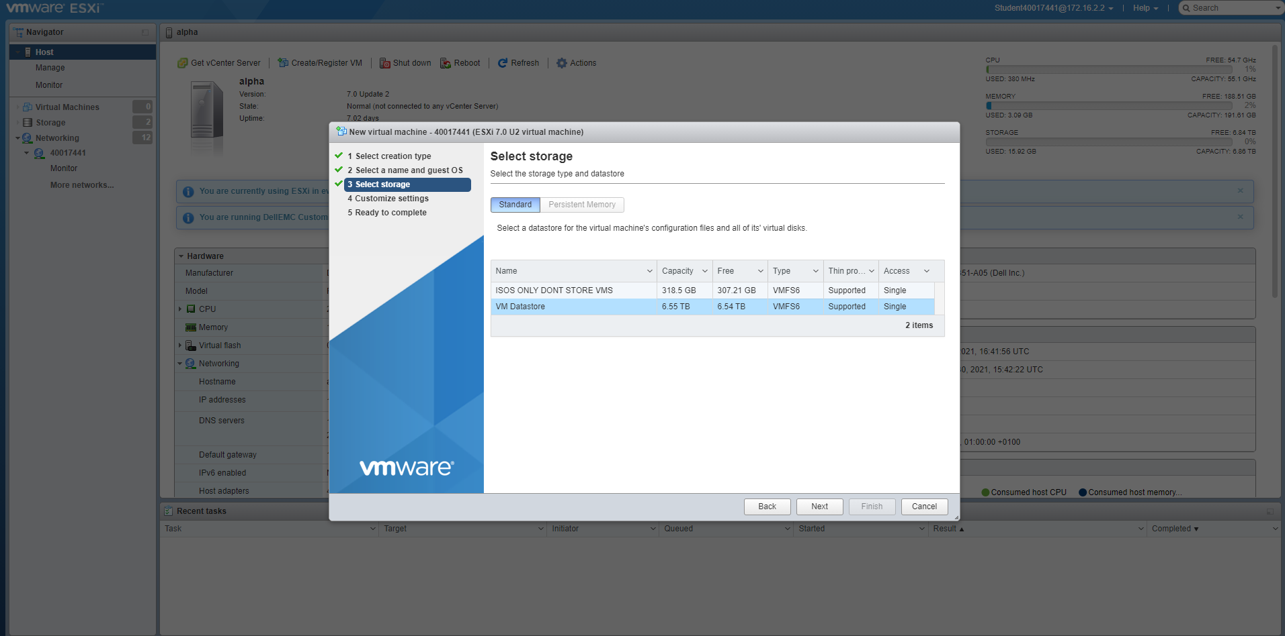You then need to create a hard drive for the VM, for this you need to select the drive you want to store your virtual hard disk on.
4. 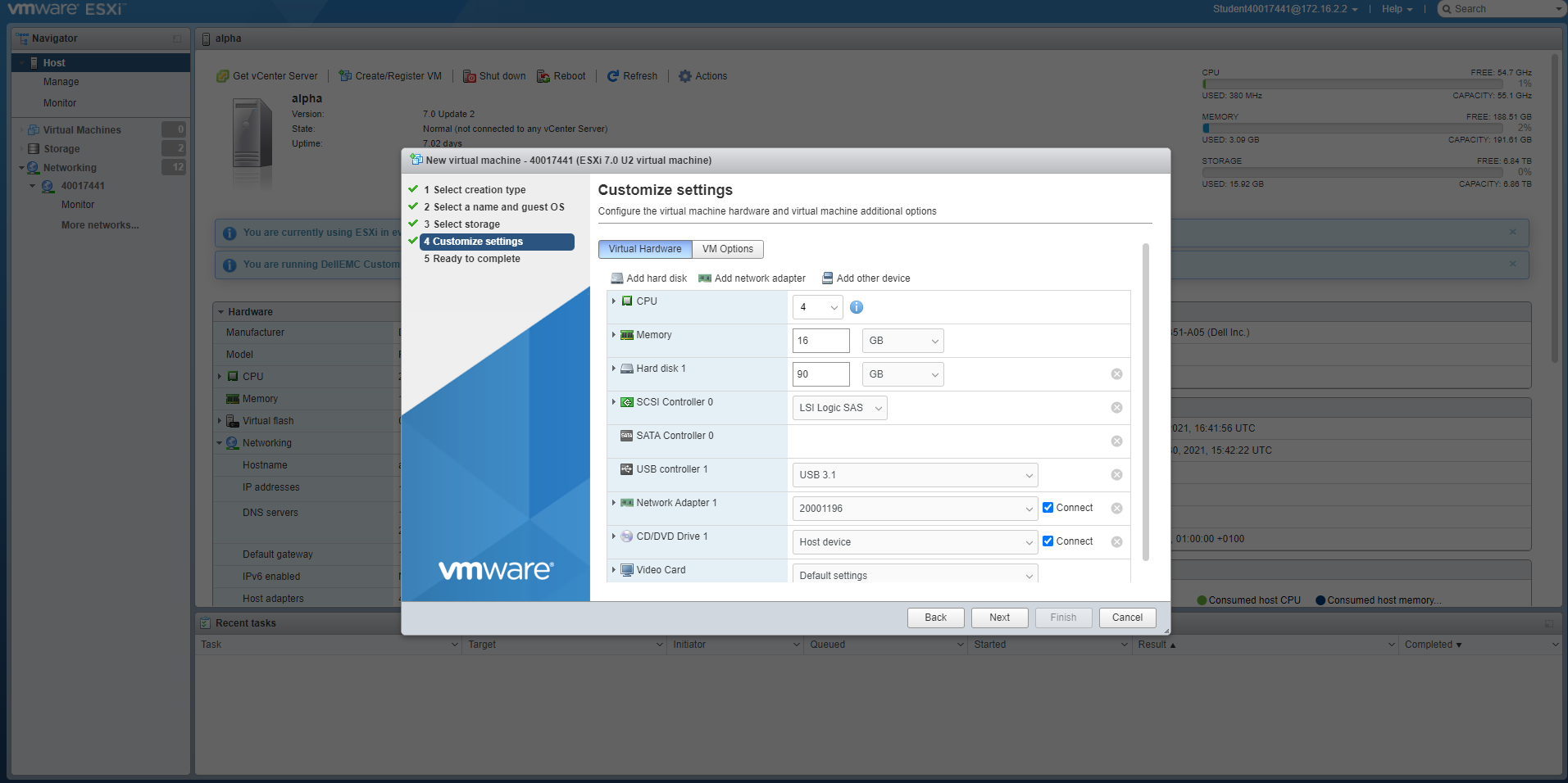Once you’ve decided where to store it, you then need to set some of the attributes of the VM, this includes how many CPU cores you want to allocate, RAM and how much Hard disk space you want to allocate it in total.
5. 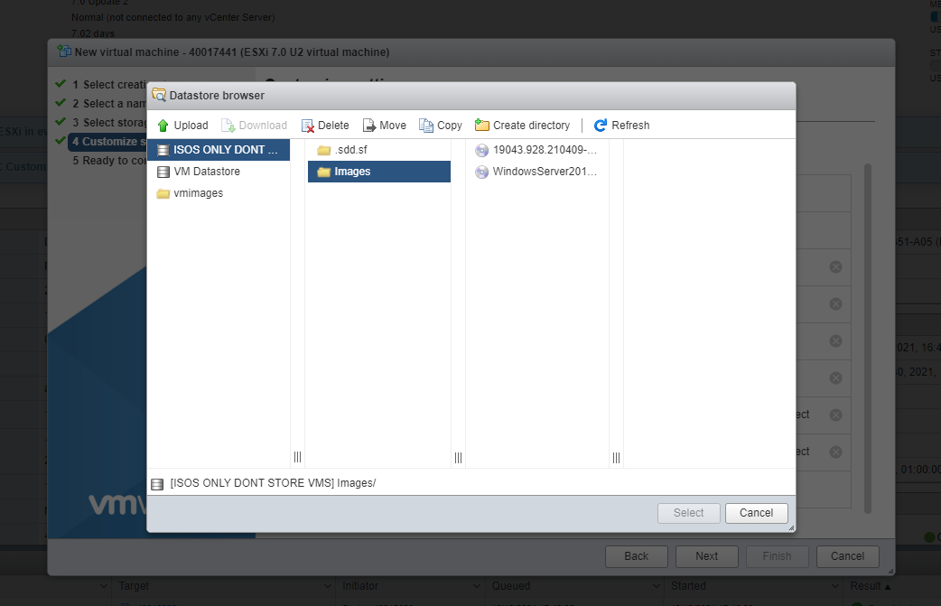In order to install Windows Server 2019, you need an ISO of it to boot it from, go to ‘CD/DVD drive’ to select where you want to boot it from.
6. 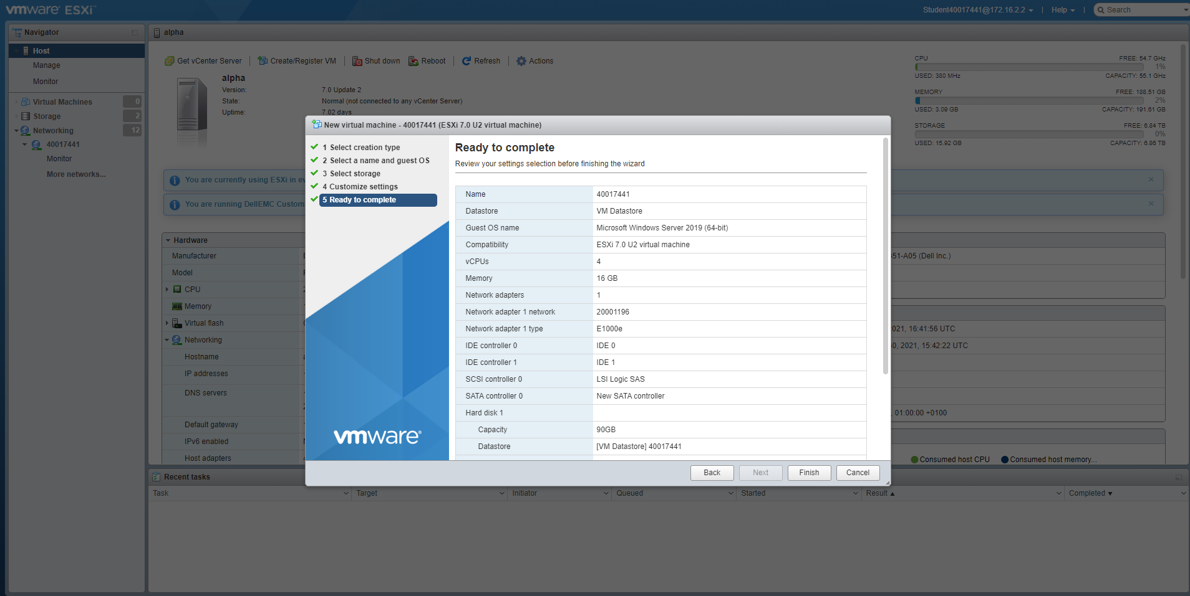Once you’ve set the settings you want, press ‘finish’ and you’ve created your VM
7. 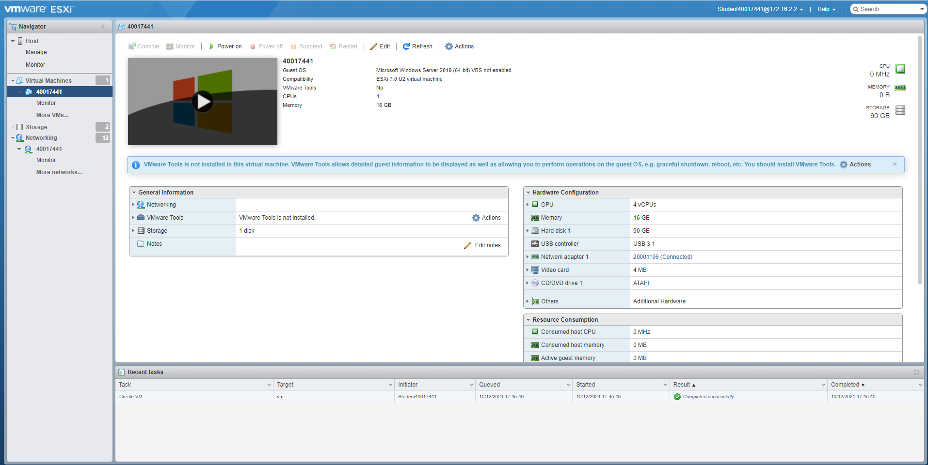Here’s the overview of your VM you just created, to boot it press the play button overlapping the Windows logo, or press the ‘Power on’ button above it.
8. Once you’ve pressed the button it will boot up for the first time and you’ll be faced with this screen, to continue just press any key, as it’ll boot from where we directed the ISO earlier.

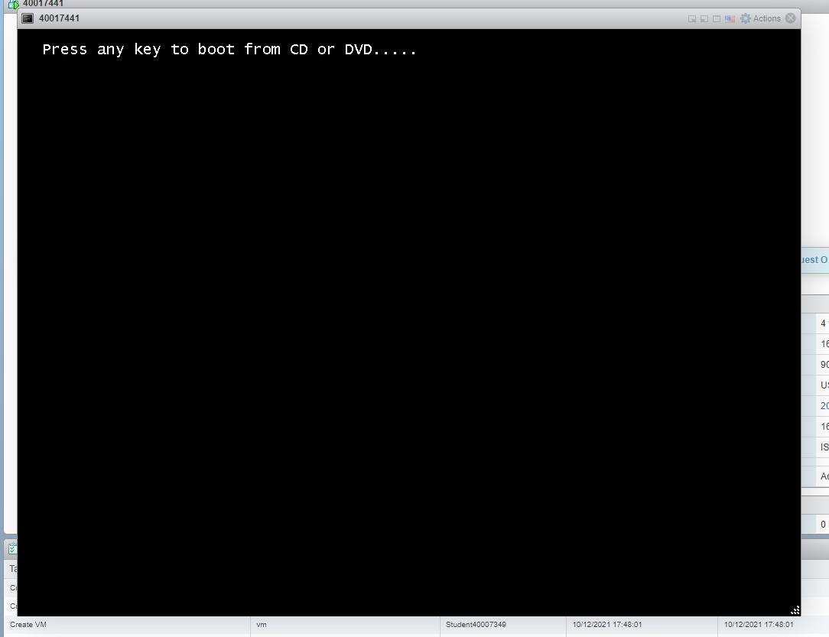

1. 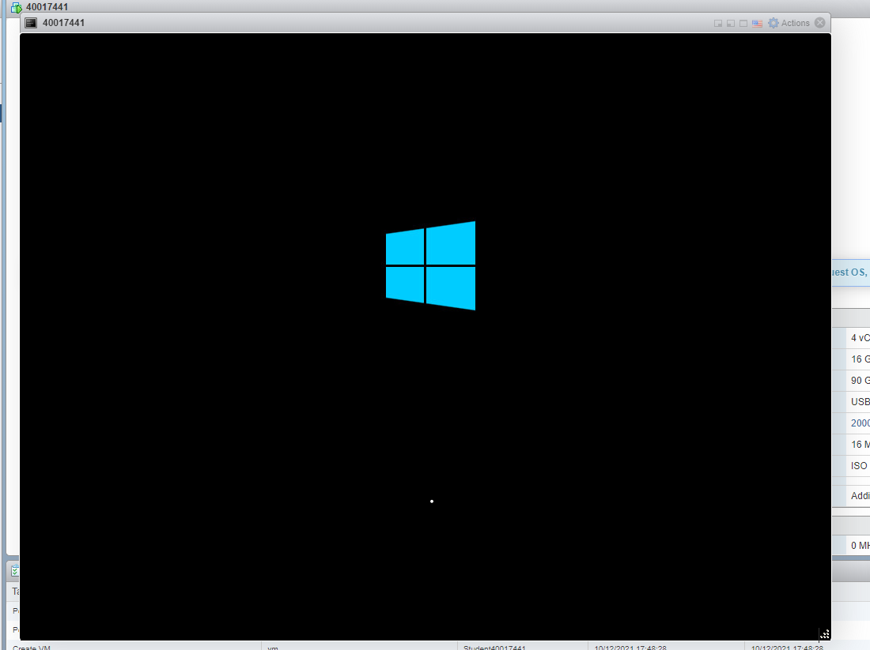If you wait through the loading screen like below it should boot you into the installer for Windows Server 2019
2. 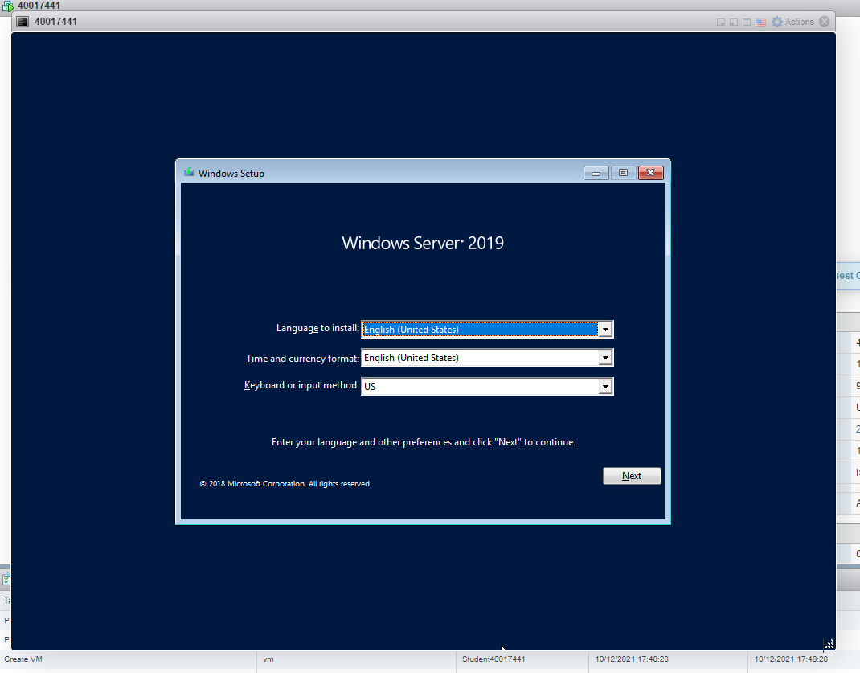You then need to select your language and keyboard or input methods
3. 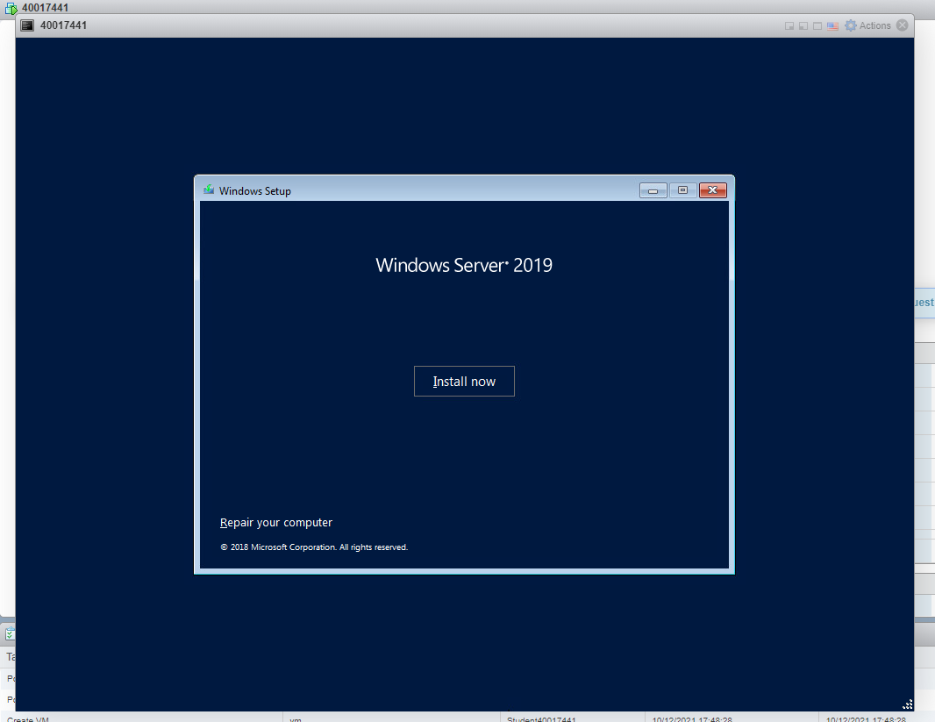And then press ‘Install now’
4. 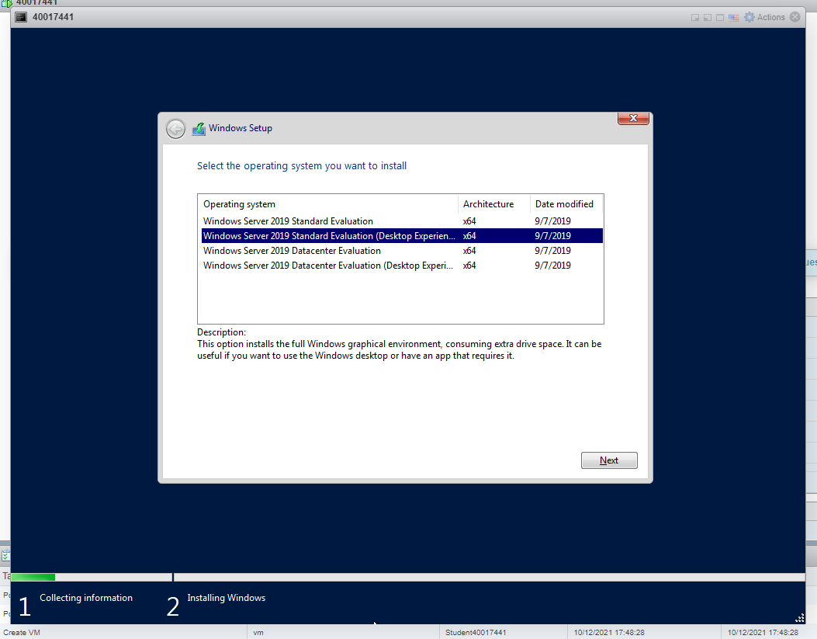It’ll then ask you for which version of Windows Server 2019 you want to install, in this case we’re going to install the standard version with a desktop experience, if you don’t install with a desktop interface, instead of being faced with the usual Windows desktop, the computer will boot into a terminal.
5. 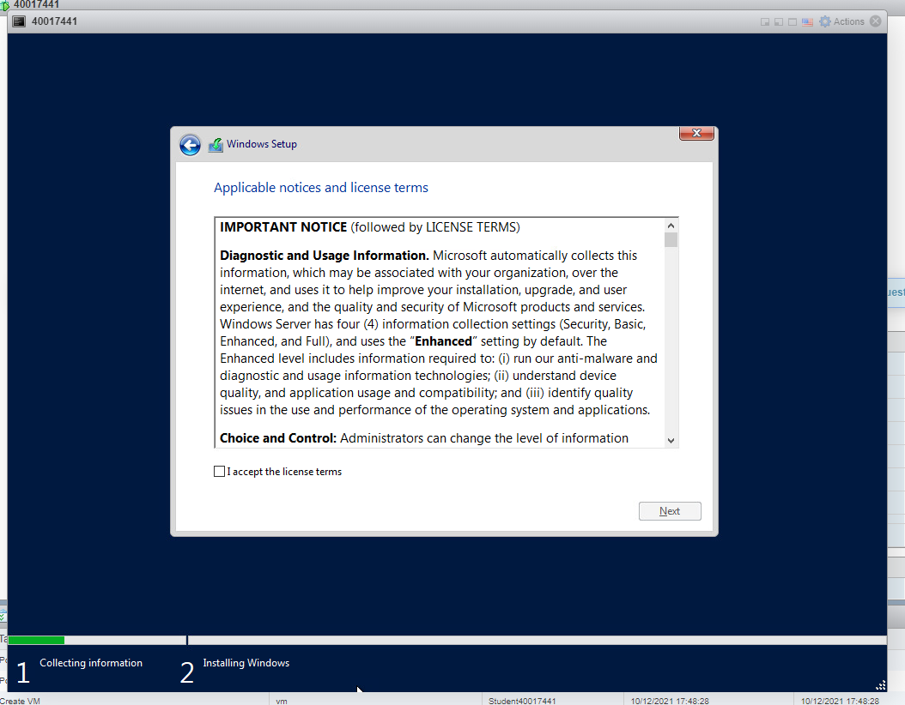You then need to agree to Microsoft’s terms of service
6. 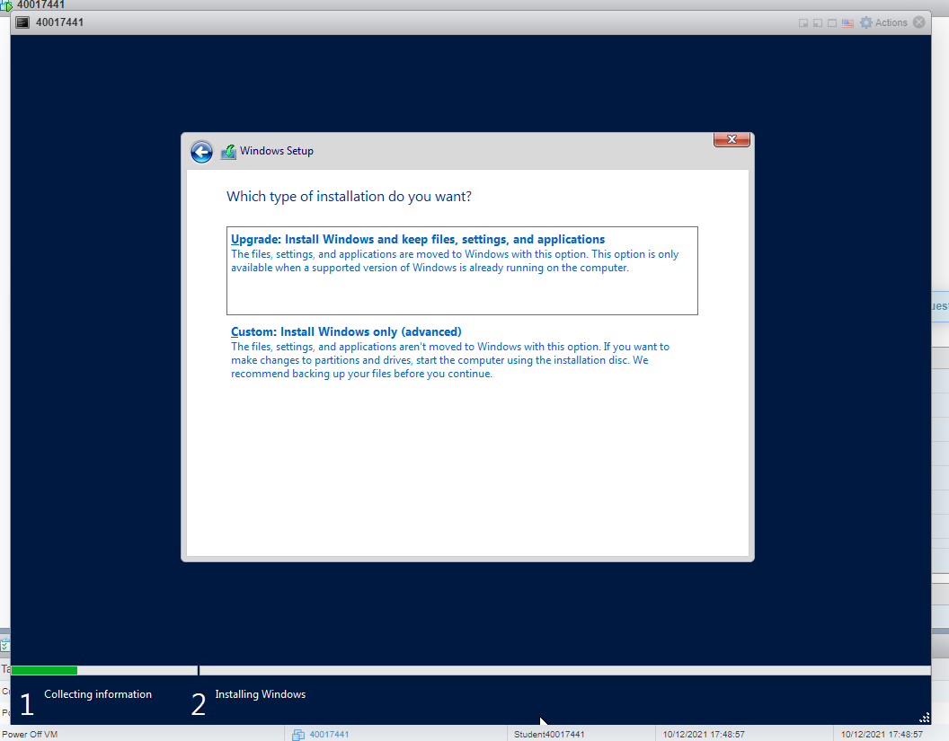You then need to select how you want to install Windows, the first option is only available to those who already have a version of Windows installed on their computer and all it will do, is overwrite the old version of Windows. If you’re booting from a fresh install with nothing else on the computer, you’ll need to select the second option which will just install Windows.
7. 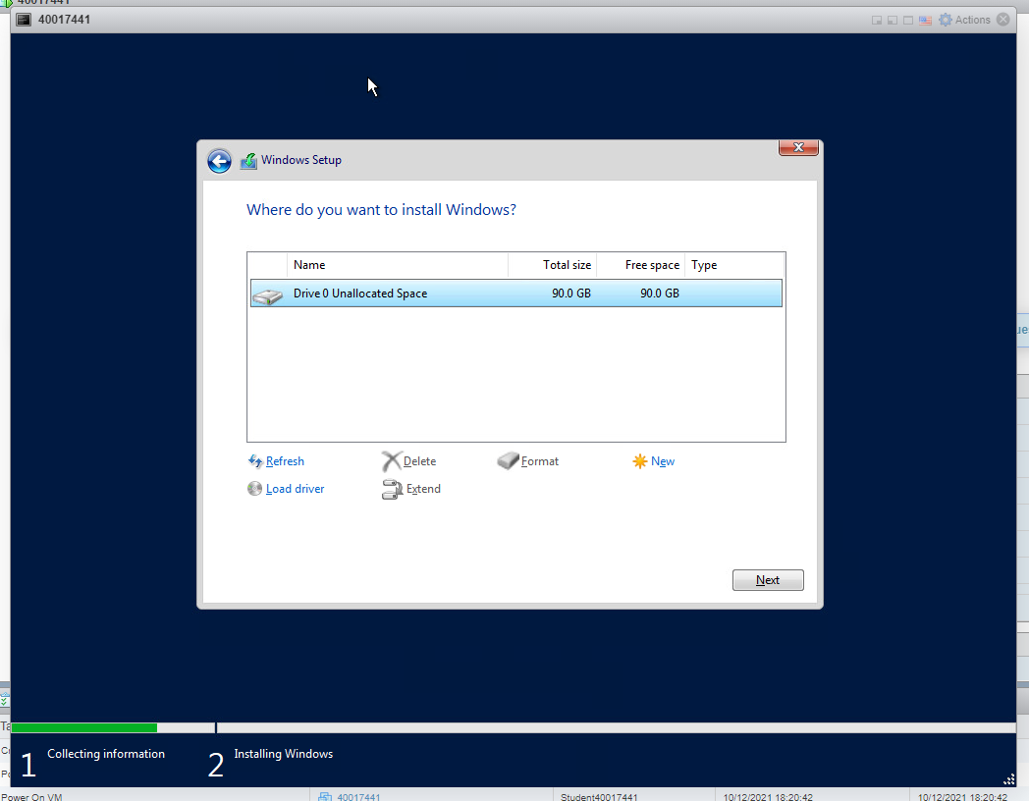For this I’ve selected the second option, from here you need to select which drive you want to install the Operating System onto, for this I’m going to install it to the only drive available to me, which we created when we created the operating system in VMware
8. Once you’ve selected the drive you want to install to, it will begin installing all the files from the ISO we loaded.

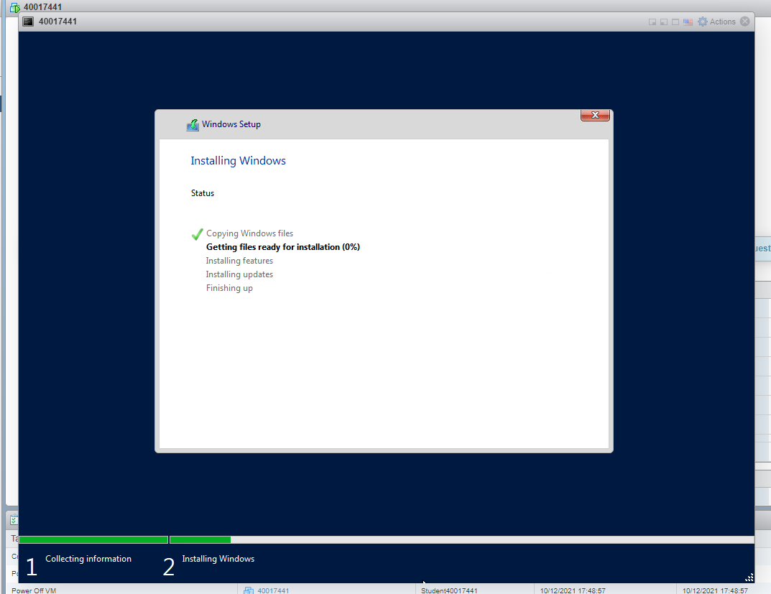

1. Once the installation is complete Windows will boot into the setup screen, where you’ll configure some of your login details and how you want to access the system. In this case, we only needed to assign a password to an Admin account (which will be created automatically as soon as you enter this screen).

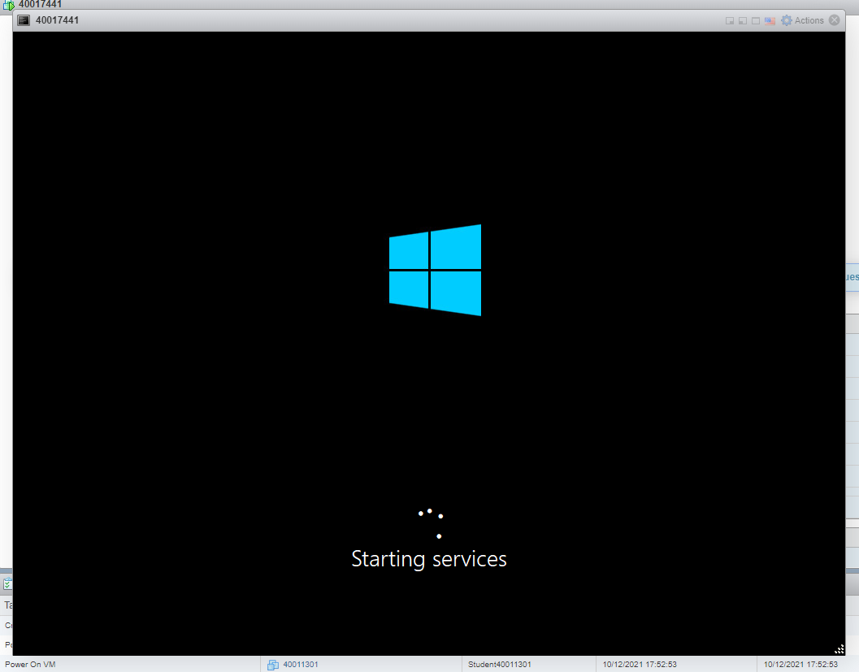

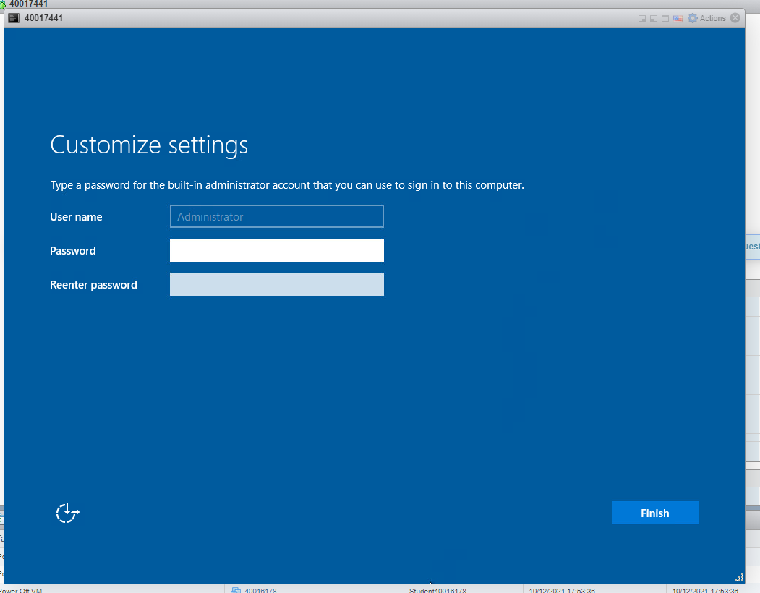

1. 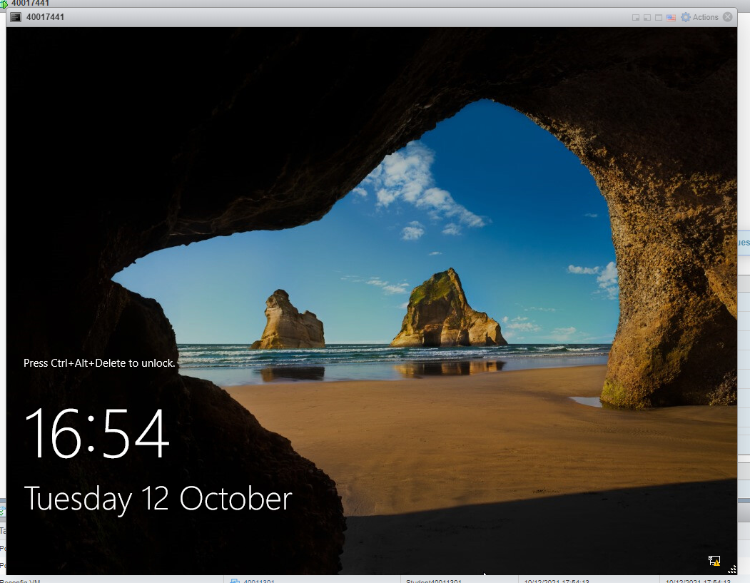Once that’s done the Operating System should boot into the Windows Desktop Environment, and you’re done.

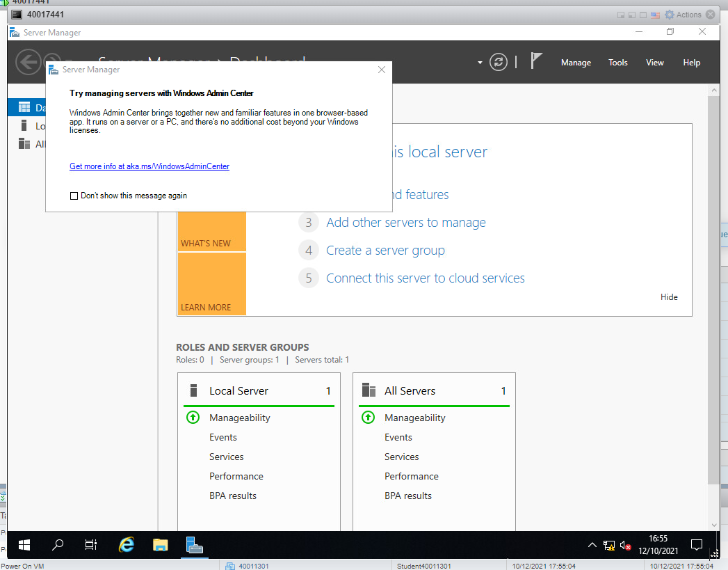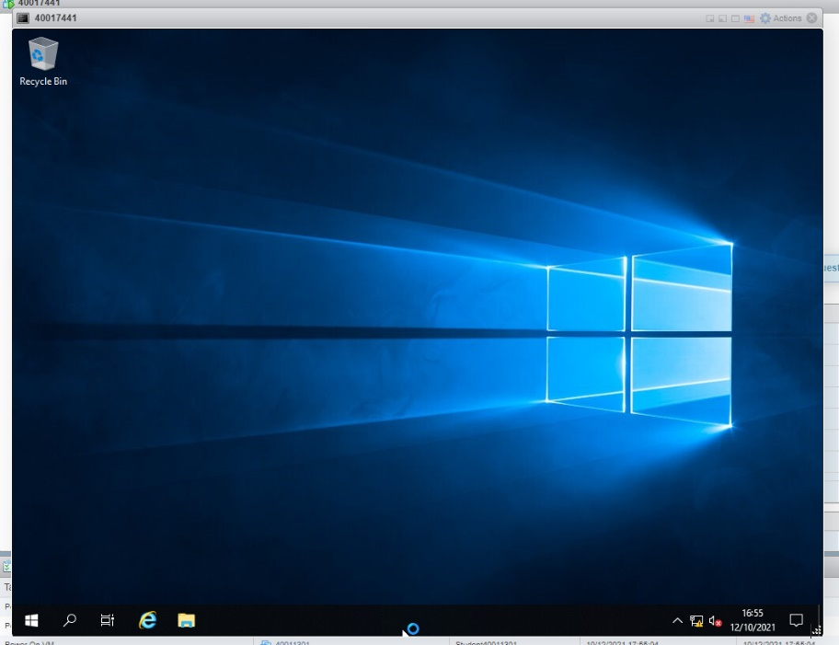

What is the difference between Server Core and Server with GUI?

When installing Windows Server, you may have noticed it displayed 2 options you could install, one with a ‘Desktop environment’ and a ‘Standard’ or ‘Core’ edition. Firstly, let’s cover what a Desktop environment would include in comparison to a server core. A server with a desktop environment or a GUI is how your standard version of Windows would look like, it’s very user and beginner friendly, being easy to navigate menus, applications and the ability to make changes quickly as if you were using a standard Windows Desktop. A server core differs in a way that it does not use such an environment and is primarily built on a command line, one thing you may wonder is why would you want to use a command line?

<https://docs.microsoft.com/en-us/windows-server/administration/server-core/what-is-server-core>